
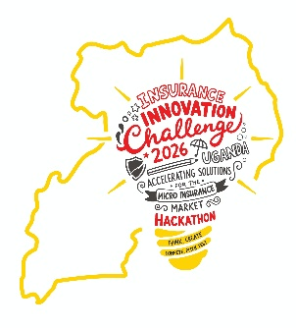
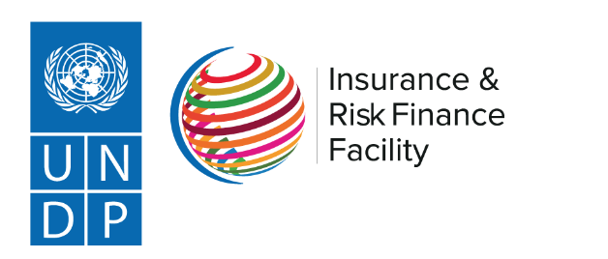

THE INSURANCE INNOVATION CHALLENGE IN UGANDA
Application Submission Form

All fields in the application form must be filled.

General Information
No. | Qn | Eligibility Criterion
1 | Name of Innovator/ company
2 | Legal Status  (Please attach your registration certificate. For startups, please attach National ID and a roadmap as guided by the mandatory selection criteria) | - InsureX graduate  - Micro-insurance company  - Insurance player with micro-insurance solution  - University-based innovator  - Technology company (Agri-Tech/Fin-Tech/Insure-Tech/Health-Tech)  - Start-up/Individual innovator
3 | Team Composition (Please attach a participant declaration letter declaring that the specified team is able to take part in the insurance innovation challenge, as guided by the mandatory selection criteria) | Please indicate the names of your team members, specifying their expertise  Core Team  Team Lead Name and expertise: ___________________  Team Members and Expertise/Roles:  ___________________  Support Team  ___________________  ___________________  Individual innovators can submit only one (1) team members
4 | Declaration documents | Please ensure that the declaration form containing the following has been signed and submitted with the application  - Regulatory Compliance  - Intellectual Property Clarity  - Data Protection and Privacy Compliance  - No Conflict of Interest

SECTION B: INNOVATION ASSESSMENT (Scored out of 100)
Innovation Name
Format of innovation | - Product  - Technology  - Service  - Approach  - ………….
Priority sector of focus
Stage of development | Please specify the stage of your innovation
Partnerships | Mention any existing partnerships, affiliations, or regulatory engagements associated with the proposed innovation.

B1. RELEVANCE / ALIGNMENT WITH NEEDS (25 marks)

- Describe the specific insurance/ risk financing/ or resilience challenge your solution addresses. What evidence is there that this challenge exists (statistics, customer feedback, studies, etc.)? (Max 200 words)

- Describe how your innovation addresses the challenge identified above, specifying how it works (Max 200 words) – Please ensure you have submitted a 2-minute video describing the innovation

- To what extent does your innovation address the core microinsurance challenges of Low insurance coverage/ uptake, Limited partnerships for microinsurance or both?

B2. ORIGINALITY / UNIQUE SELLING POINT (10 marks)

- What makes your solution new or significantly different from existing insurance products, services, or models in Uganda? What is the unique selling point? (Max 150 words)

- Describe the creative or disruptive element of your approach (technology, distribution, business model, or service design). Clearly mention all the disruptive elements that your solution has that make it creative (Max 150 words)

B3. INCLUSION PARAMETERS (15 marks)

- Which underserved groups does your solution specifically target, how and why?

- How is your solution designed (design features e.g. usage etc.) to be accessible and usable by your target marginalized group? Explain the innovative design features. (Max 200 words)?

B4. FEASIBILITY (15 marks)

- What technical, operational, and regulatory requirements are needed to implement your solution? How will you meet them? (Max 200 words)

Technical:___________________________________________________________________________________
Operational: __________________________________________________________________________________
Regulatory: _______________________________________________________________________________

- What is your current operational capacity (team, infrastructure, partnerships) to deliver this solution? (Max 150 words)

- Please specify the main acceleration challenge that your innovation Is currently facing and how this Insurance Innovation Challenge can help you address this challenge (Max 150 words)

B5. SCALABILITY & MARKET POTENTIAL (25 marks)

- What is the current traction of your solution (Who are the current users and how many? What milestones have you achieved so far? (Max 200 words)

- Describe your target market size and the competitive positioning of your solution. How large is the market, and who are the competitors. What is the projected market? (Max 200)
- What are the unique avenues through which your innovation can be scaled (for example into other microinsurance sectors, other actors etc.) (core evaluation area)?

- Please provide evidence of a credible, scalable distribution partner or channel, the size of the pool it reaches, and a realistic path from pilot to scale (core evaluation area).

B6. SUSTAINABILITY (10 marks)

- How will your solution generate revenue and remain financially viable beyond the funding period (in case you win this award)? (Max 200 words)

- Identify potential negative impacts or risks of your solution and how you will mitigate them. (Max 150 words)

OTHER COMMENTS: Please provide any additional information that may aid the evaluation committee in determining if your innovation meets the criteria for selection

I/We declare that:
1. All information provided in this application is true and accurate.
2. We understand that false statements will result in disqualification.
3. We agree to comply with all challenge rules, timelines, and ethical standards.
4. We consent to UNDP and IRA using the submitted information for evaluation and program purposes.
Signature of Team Lead: _________________________ Date: _________________

Submit this form together with the signed declaration form, the 2-minute video and any other attachments (e.g., company registration, etc)following documents to projects@adroitconsultinternational.com copying in ira.sandbox@ira.go.ug
THE END

