
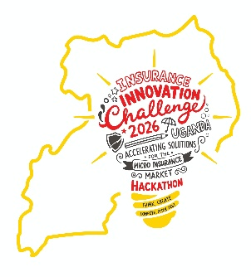
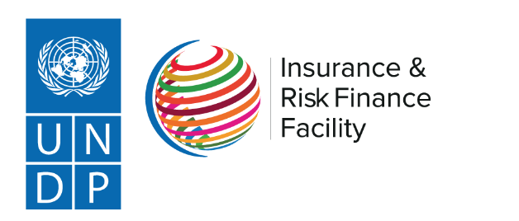

THE INSURANCE INNOVATION CHALLENGE IN UGANDA

PARTICIPANT DECLARATION FORM

Declaration
I, the undersigned, being the duly authorized representative of the above-named applicant, hereby declare and confirm the following on behalf of myself, my organization, and all members of the team:

- Conflict of Interest Declaration:
I declare that neither I, my organization, nor any member of the team has any actual, potential, or perceived conflict of interest that could improperly influence participation in, or the outcome of the Insurance Innovation Challenge in Uganda.

I further declare that:
- We do not have any existing personal, professional, financial, or institutional relationships that may reasonably be perceived as creating a conflict of interest.
- We do not have any undisclosed relationship with personnel of UNDP, the Insurance Regulatory Authority of Uganda (IRA), Adroit Consult International, Microinsurance Master, members of the judging panel, mentors, evaluators, facilitators, or any individual involved in the administration of the Challenge that could influence the evaluation or selection process.
- Should any actual, potential, or perceived conflict of interest arise during the Challenge period, we shall immediately disclose it in writing to the organizers.

- Regulatory Compliance Declaration:
We acknowledge and agree that participation in the Innovation Challenge does not exempt us from complying with applicable laws, regulations and regulatory requirements governing insurance and financial services in Uganda.

We further declare that:
- We are willing to comply with all applicable regulatory requirements of the Insurance Regulatory Authority of Uganda (IRA), including participation in regulatory sandbox testing where applicable.
- Neither the organization nor any team member is currently subject to regulatory sanctions, enforcement actions, investigations, suspensions or legal restrictions that would materially affect participation in the Challenge.
- All information submitted regarding regulatory status is accurate and complete.

- Intellectual Property Declaration:
We declare that:
- We own, control or possess the necessary rights, licenses, permissions and authorizations to use all intellectual property associated with the proposed innovation.
- To the best of our knowledge, the proposed solution does not infringe upon the intellectual property rights of any third party.
- There are no ongoing legal disputes, claims or proceedings relating to the ownership or use of the intellectual property underlying the proposed innovation.
- Any third-party technologies, software, content or intellectual property incorporated into the solution have been properly licensed or authorized for use.

- Data Protection and Privacy Compliance:
We acknowledge the importance of protecting personal and sensitive information and commit to complying with applicable data protection requirements.

We declare that:
- We understand and will comply with the provisions of the Data Protection and Privacy Act, 2019 and any other applicable data protection regulations.
- We shall implement appropriate safeguards to ensure the confidentiality, integrity and security of customer and stakeholder data.
- We shall only collect, process, store and share personal information in accordance with applicable legal and ethical standards.

- Accuracy and Truthfulness of Information:
We certify that:
- All information provided in the application, supporting documents, presentations and declarations is true, accurate, complete and not misleading.
- Any material changes affecting the information submitted shall be promptly communicated to the organizers.
- We understand that any false declaration, omission, misrepresentation or failure to disclose relevant information may result in disqualification from the Challenge.

- Acknowledgement of Consequences:
We understand and accept that the organizers reserve the right to verify any information provided and may disqualify an applicant at any stage of the process where:
- A conflict of interest is identified and not disclosed;
- False or misleading information is provided;
- Regulatory non-compliance is established;
- Intellectual property ownership cannot be adequately demonstrated;
- Data protection requirements are not met; or
- Any conduct is identified that may compromise the integrity, transparency or credibility of the Innovation Challenge.

Certification:
I hereby certify that I have read, understood and agree to the declarations contained in this document and that I am authorized to make this declaration on behalf of the applicant organization and proposed team.

Name:
Position:
Organization:
Signature:
Date:
Official Stamp/Seal (where applicable):

